|  |  |  |  |  |  |  |  |  |
| --- | --- | --- | --- | --- | --- | --- | --- | --- |
| |  | | --- | | Tidal Audio Streamer ARKAS | | https://audiohoanghai.com/media/product/9422_111.png |  |  |  |  |  | | --- | --- | --- | --- | | https://audiohoanghai.com/media/product/9422_111.png | https://audiohoanghai.com/media/product/9422_tidalintraweb3.jpg | https://audiohoanghai.com/media/product/9422_tidal_arkas_back1_960x750.jpg |  | |  | **Specifications:**  **TIDAL Arkas**: LAN/USB input digital music transmitter with oversized linear power supply and SPDIF/USB/TIDAL-LINK output  Oversized power transformer with magnetic protection, buffer capacity more than 200,000µF  **Music data streaming input:** LAN ethernet (1000BASE-T), USB storage/hard disk (one partition FAT32, NTFS, exFAT, EXT2/3)  **SPDIF output**: AES/EUB, Coaxial RCA, Coaxial BNC, Toslink Optical. PCM 44.1-192KHz, 16-24bit. DSD (DoP, DSD over PCM) 2.8MHz, 1bit.  **USB output:** up to DSD256 (native/DoP), PCM 44.1-384KHz, 16-32bit  TIDAL-LINK output: proprietary music data protocol output directly to TIDAL Camira DMC  **Price: 38$** |

**Overview:**

Audio Streamer Tidal ARKAS | Audio FOTOLAB

TIDAL Arkas is designed to be the perfect digital music controller for TIDAL's high-end systems. Arkas's philosophy is simple: build a perfect music file transfer system with TIDAL performance and reliability. Overall, the TIDAL Arkas concept can be compared to building a super sports car: as little weight as possible, by eliminating all that is really necessary, combined with the most power possible - to get the best performance and keep up the pace.

It may seem unusual, but it makes a lot of sense to come to Arkas's mind, that Tidal simply decided not to build an internal file storage system and only used the relevant core technology around it. around a powerful power source and combine it with a single file transfer output. All components with a digital half-life such as music data storage, NAS systems/music servers and hard drives, are external to TIDAL Arkas.

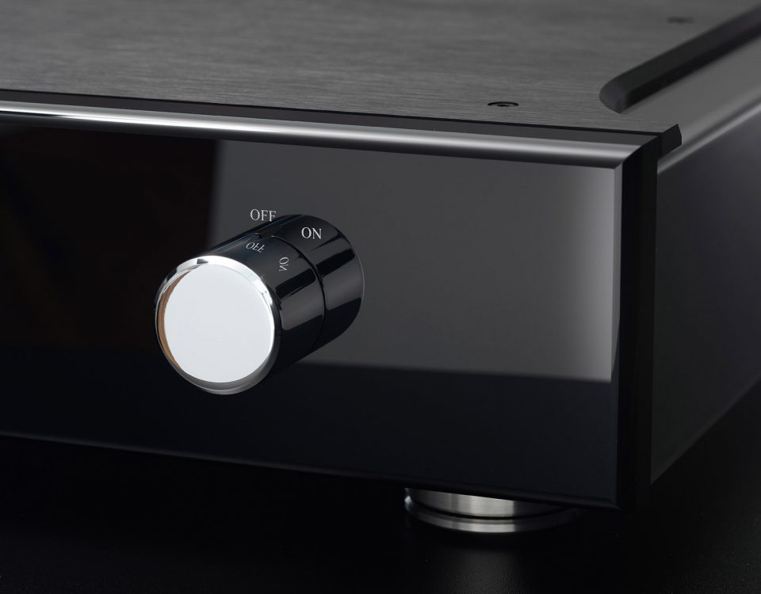

In this way, TIDAL Arkas remains an elite streamer for many years, because some things will not change as quickly as digital technology: our TIDAL digital players and the power supply inside Arkas are ready to use for many years to come. Peripheral components to run the PCB, as well as the streaming PCB itself, are designed for upgrade and adjustment - protecting the customer's equipment and ensuring the best sound for the customer's TIDAL system row. Whatever the future brings, Arkas is prepared.

Every Arkas comes with a proprietary data connection output to the TIDAL Camira (2021) - we call it TIDAL-Link. This unique cable connection overcomes the disadvantages of SPDIF RCA, AES or USB in terms of sound quality and lack of ability to play certain files using certain connections. A TIDAL link cable comes with every Arkas, ready to be plugged into the TIDAL Camira to unleash its true performance and create the perfect TIDAL combination.

At Audio Hoang Hai, all products are imported genuine, customers will enjoy the manufacturer's warranty when purchasing.